BUNKERMANIA 2023
PLASTIC MODEL SHOW AND CONTEST
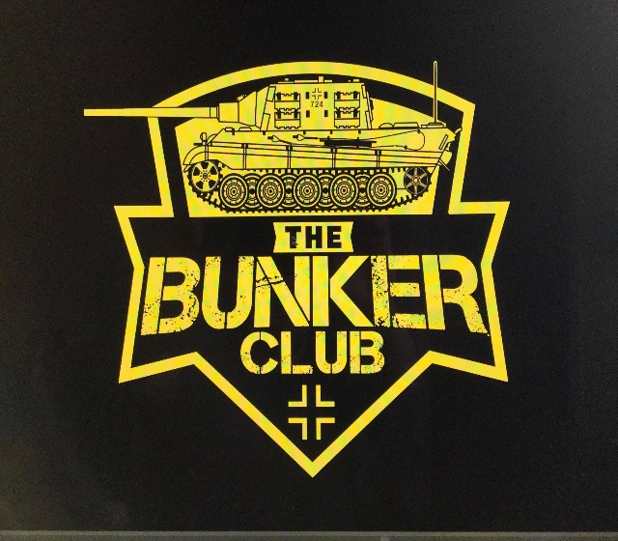
Saturday, Nov. 18th Clyde Fire Hall
CONCESSIONS
1050 CLYDE ROAD
NEW FLORENCE, PA
ADMISSION AND REGISTRATION OPEN AT 9AM
REGISTRATION CLOSES AND JUDGING STARTS AT 12PM
AWARDS TO FOLLOW
RAFFLES
VENDORS
SPECIAL AWARDS INCLUDE:
- BEST OVERALL ARMOR
- BEST OVERALL AIRCRAFT
- BEST KOREAN ARMOR (SGT. GEORGE FRITZ AWARD)
- BEST JAGTIGER TANK (THE BUNKER CLUB MASCOT)
- BEST RUSSIAN ARMOR (SGT. MAJOR EARL AWARD)
- BEST LUFTWAFFE
- BEST MARINE CORP MODEL
- BEST JUNIOR MODEL
- BEST YOUTH MODEL
- BEST AUTOMOTIVE MODEL
- BEST DINOSAUR
- BEST FIGURE
- BEST SHIP
- BEST MISCEALLANEOUS MODEL
- BEST SCI-FI MODEL
- BEST MOVIE MODEL
- BEST DIORAMA
- BEST BUST
- BEST SPACE MODEL
- BEST HORROR MODEL

CONTEST CATEGORIES:
AIRCRAFT
ARMOR
AUTOMOTIVE
DINOSAURS
DIORAMAS
FIGURES
JUNIORS (AGES 13-17)
YOUTH (AGES 12 AND YOUNGER)
SCI-FI
SPACE
MOVIES
SHIPS
HORROR

GENERAL ADMISSION $3, UNDER 12 FREE
$10 ADULT ENTRY FEE FOR FIRST 3 MODELS ($1 FOR EACH ADDITIONAL MODEL)
$3 JUNIOR ENTRY FEE (UNLIMITED MODELS)

FOR MORE INFORMATION
SEARCH “THE BUNKER CLUB” ON FACEBOOK
OR
CALL, TEXT, OR EMAIL TROY FRITZ
724-599-4885
FRANKCASTLE31@YAHOO.COM
VENDOR TABLE FEE $10
SPONSORS:
SPONSERS:

