

BUNKERMANIA 2025

PLASTIC MODEL SHOW

AND CONTEST

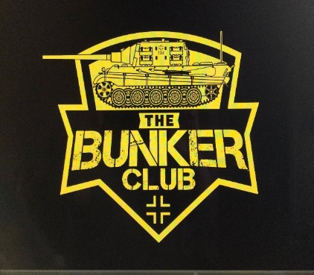 Saturday, November 8th Quality Inn and Suites

CONCESSIONS

VENDORS

RAFFLES

**1545 WAYNE AVE**

**INDIANA, PA**

**ADMISSION AND REGISTRATION OPEN AT 9AM**

**REGISTRATION CLOSES AND JUDGING STARTS AT 12PM**

**AWARDS TO FOLLOW**

**GENERAL ADMISSION $5, UNDER 12 FREE**

**$10 ADULT ENTRY FEE FOR FIRST 3 MODELS ($1 FOR EACH ADDITIONAL MODEL)**

**$3 JUNIOR ENTRY FEE (UNLIMITED MODELS)**

**SPECIAL AWARDS INCLUDE:**

* **BEST OVERALL ARMOR (CHAMPIONSHIP BELT AWARDED)**
* **BEST OVERALL AIRCRAFT (CHAMPIONSHIP BELT AWARDED)**
* **BEST OVERALL AUTOMOBILE (CHAMIONSHIP BELT AWARDED)**
* **BEST KOREAN ARMOR (SGT. GEORGE FRITZ AWARD)**
* **BEST JAGTIGER TANK (THE BUNKER CLUB MASCOT)**
* **BEST RUSSIAN ARMOR**
* **BEST LUFTWAFFE**
* **BEST MARINE CORP MODEL**
* **BEST JUNIOR MODEL**
* **BEST YOUTH MODEL**
* **BEST CAR MODEL**
* **BEST DINOSAUR**
* **BEST FIGURE**
* **BEST SHIP**
* **BEST HORROR MODEL**
* **BEST SCI-FI MODEL**
* **BEST MOVIE MODEL**
* **BEST DIORAMA**
* **BEST BUST**
* **BEST SPACE MODEL**

**CONTEST CATEGORIES:**

**AIRCRAFT**

**ARMOR**

**AUTOMOTIVE**

**BUSTS**

**DINOSAURS**

**DIORAMAS**

**FIGURES**

**HORROR**

**JUNIORS (AGES 13-17)**

**MOVIES**

**SCI-FI**

**SHIPS**

**SPACE**

**YOUTH (AGES 12 AND YOUNGER)**

****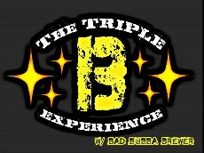

**SPONSORS:**

**FOR MORE INFORMATION SEARCH**

**“THE BUNKER CLUB” ON FACEBOOK**

**or**

**CALL, TEXT, OR EMAIL TROY FRITZ**

**724-599-4885**

**FRANKCASTLE31@YAHOO.COM**

**VENDOR TABLE FEE $15**

**SPONSERS:**