Model Categories
401: Junior - All categories (Under 13 years of age)
402: Senior - All categories (13-17 years of age)
403: Box Stock – See rule #3.
404: Street Rod (non-stock street vehicle 1950 & older)
405: Street Machine (non-stock street vehicle 1951 & newer)
406: Factory/Showroom Stock
410: Competition, Drag (any straight line racer)
411: Competition, Open-Wheel
412: Competition, Closed Wheel
420: Foreign & Exotic
430: Heavy Truck/Commercial/Emergency (>1 ton capacity)
431: Light Truck/Commercial/Emergency (1 ton or less capacity)
440: Large Scale (1/18 & larger)
441: Small Scale (1/32 & smaller)
450: Curbside (no visible engine)
451: Miscellaneous (anything that doesn’t other categories)
460: Custom
461: Low Riders
470: Slammers (no engine or interior)
480: Motorcycles
490 Dioramas

Please see the club web site for full descriptions of model categories:
www.ipms-hams.org

Special Awards

Best Engine
Best Interior
Best Paint
Best ’32 Ford
People’s Choice
Theme Award
Best in Show

Contest Rules
- All models must be the work of the entrant and the entrant only. Entries by proxy are welcome.
- Models may be made from any material, not just plastic.
- Any model may be entered as long as it has not won any awards at a previous HAMS show.
- Box Stock entries must be accompanied by the kit instructions. The model must be built only from parts supplied in the kit and each part must be used in the way the kit manufacturer intended. Design flaws may not be corrected. Removal of parting lines or injection points, filling of sink holes, re-chroming of flawed chrome, and use of replacement parts from an identical kit is allowed. Paint, foil, flocking or decals from any source is allowed.
- Pre-painted models are allowed in the Junior category only.
- Any base, figures, etc, that accompany a non-diorama entry will not be judged – only the vehicle will be judged. The only exceptions to this are the truck (where any load being carried will also be judged) & diorama categories.
- Military Vehicles are allowed in any appropriate category as long as they are wheeled-only. No fully or partially tracked military vehicles allowed (i.e. tank or halftrack). However, fully or partially tracked civilian vehicles are allowed (i.e. bulldozer or snowcat).
- “No Sweep” rule: No individual can win more than 2 places in any one category unless they have the only entries in that category.
- “Politicking” for any model is not allowed. Any abuse of this rule may result in the model and/or person being removed from the contest.

Directions and Map

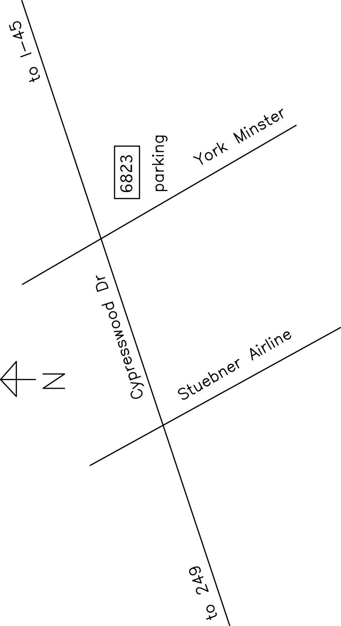

Spring, Texas, is located on the north side of Houston. To reach the Cypress Creek Christian Community Center Annex Building:

From I-45, take the Cypresswood Dr. exit and travel west 5.46 miles. Turn left onto York Minster, then left in the parking lot.

From SR 249, take the Cypresswood exit and travel east 4.02 miles. Turn right onto York Minster, then left into the parking lot.
Houston Automotive Modelers Society
Tenth Annual Model Car Show and Contest

Saturday, July 30, 2016
9:30Am until 5:00 PM

Cypress Creek Christian Community Center
Annex Building Gym
6823 Cypresswood Drive
Spring, Texas 77379

www.ipms-hams.org

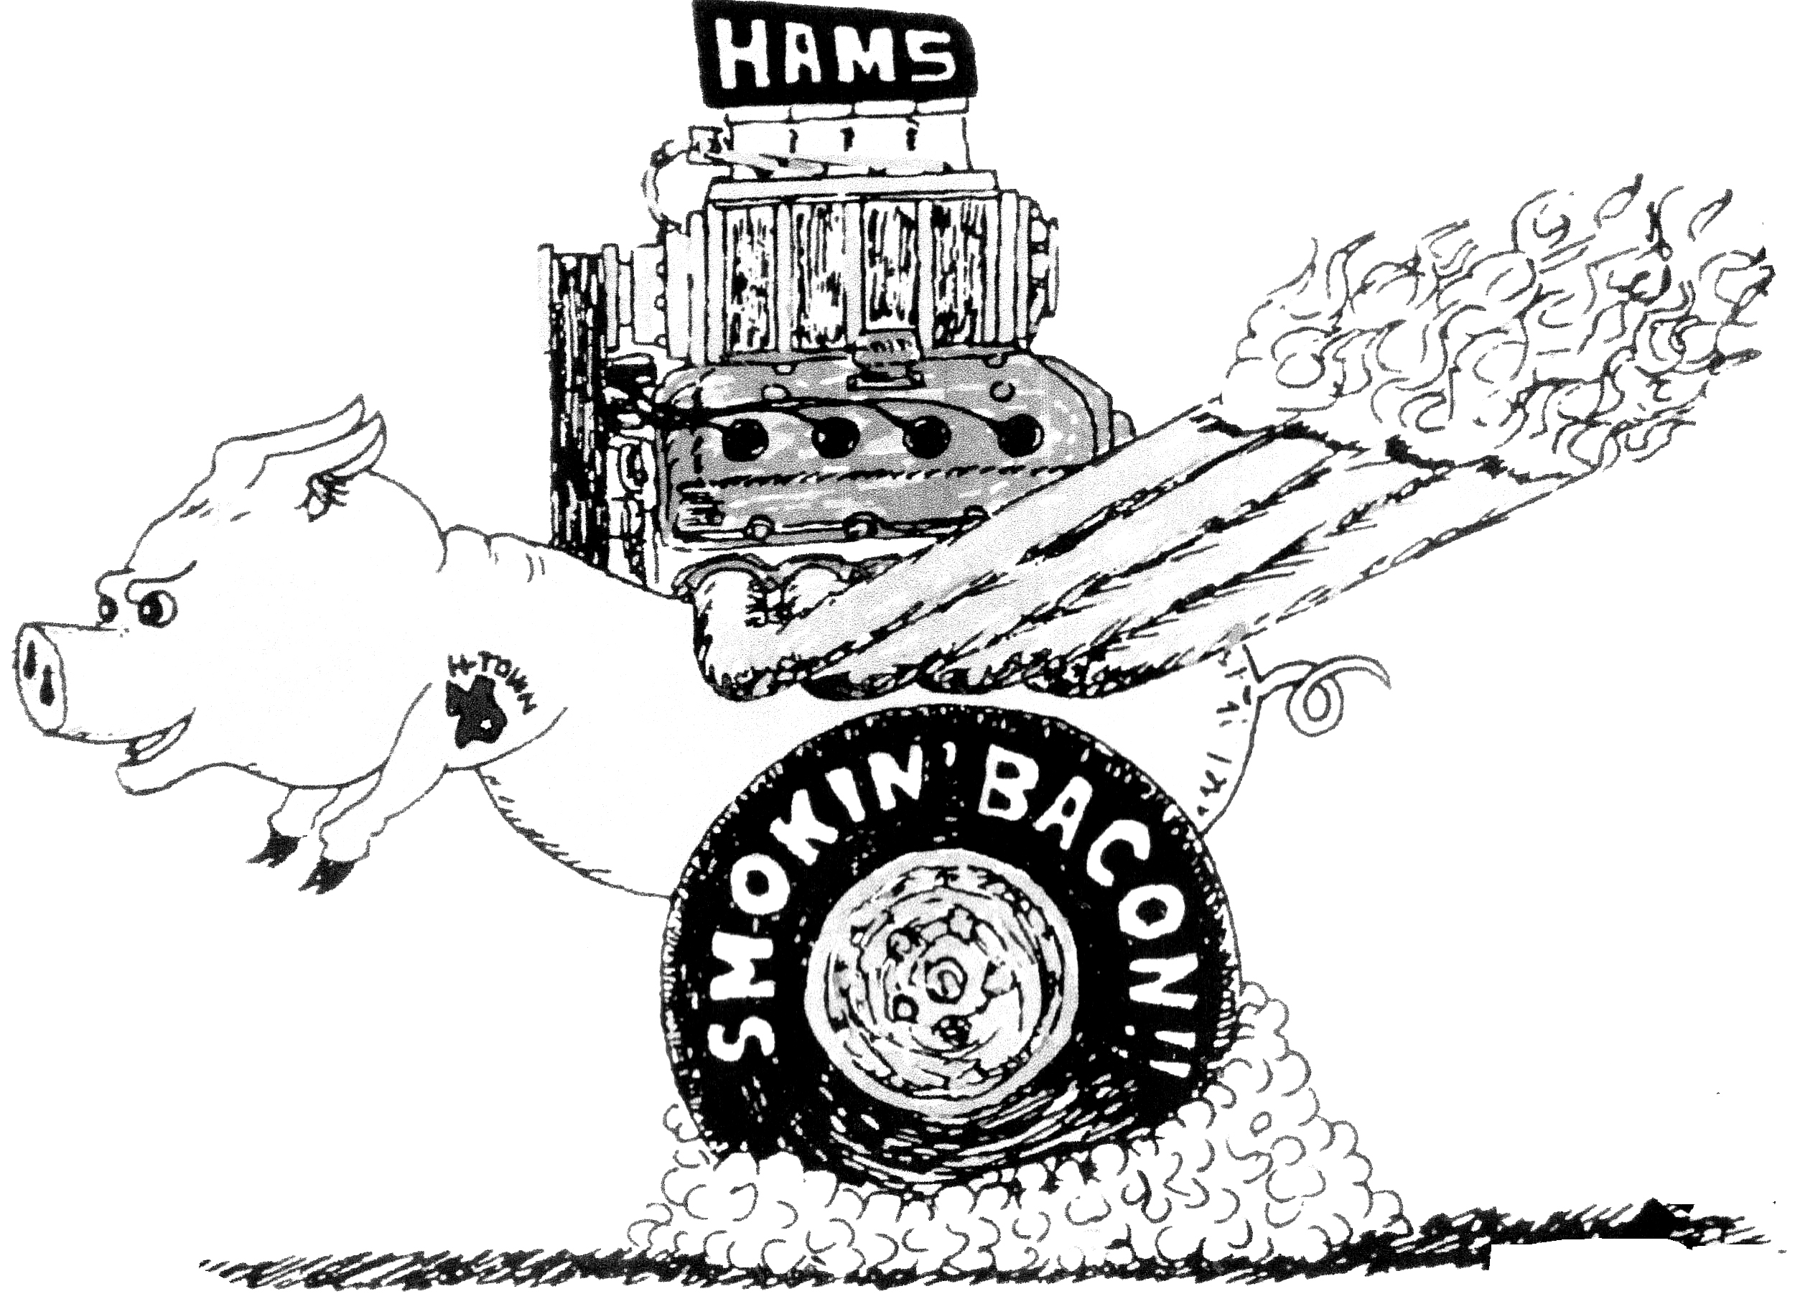

2016 Theme:
“100th Running of the Indy 500”

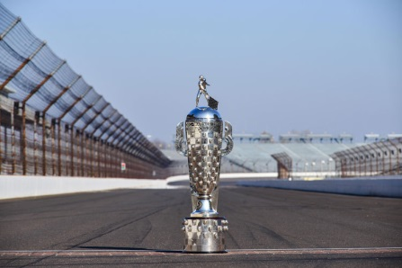

Any race car that qualified, attempted to, or competed (like Miller, Kurtis-Novi, Lotus-Ford, Eagle-Offy and many others), Pace and track official cars (including USAC, CART, IRL), track rescue vehicles (the Holmatro-Safety-Team for example), Speedway security vehicles or any vehicle verified as being part of any Indy 500 related activity at IMS since 1911.

Awards will be presented in 21 categories (first, second, & third places) along with seven special awards.

Model contest room will be left open to the public during judging.

Supported by
Cypress Creek Christian Community Center

Event Schedule

8:00 AM to 9:30 AM Vendor set up only.
9:30 AM to 5:00 PM Show open to public.
9:30 AM to 1:00 PM Contest entries accepted.
1:00 PM to 3:00 PM Make-N-Take
1:30 PM to 3:30 PM Contest Judging.
3:30 PM to 4:00 PM Awards presentation.
4:00 PM to 5:00 PM Display & vendor tear down.

Entry Fees:

General Admission: $1
Contest Entry (18 & over): $10 for first 2 entries
$2 each additional entry
Contest Entry (13 to 17): $5 for first 2 entries
$1 each additional entry
Contest Entry (12 & under): $1 for all you can enter

Vendor Tables are available on a first reserved basis. $20 each if reserved before July 8, 2016. $25 each after that date

Trophy sponsorships are available at $25 for each category (first, second, third places) or $25 each for special awards.

For vendor tables & trophy sponsorships, please Contact Show Chairman Rob McQuown at
281-731-6566 or 281-537-6957 Email: robert.mcquown@sbcglobal.net.

Make & Take
Children 13 and under will be able to build a free model car at the Make-N-Take table. One model per child.

Food
While there are several fine restaurants in the area, food and drink will be available at the show venue for a nominal cost.

