ModelZona 2022
The Phoenix, AZ Craig Hewitt Chapter of the IPMS/USA invites you for a day of fun (and a little Model Contest) at Red Mountain Community Church 6101 East Virginia Street Mesa, Arizona 85215 (North east corner of Loop 202 and N. Recker Road) - Saturday November 5th 2022, 09:00 AM to 4:00 PM.
OPEN TO ALL MODELERS
40+ CATEGORIES
SEMINARS
MAKE & TAKE
VENDOR TABLES

SPECIAL THEME AWARDS
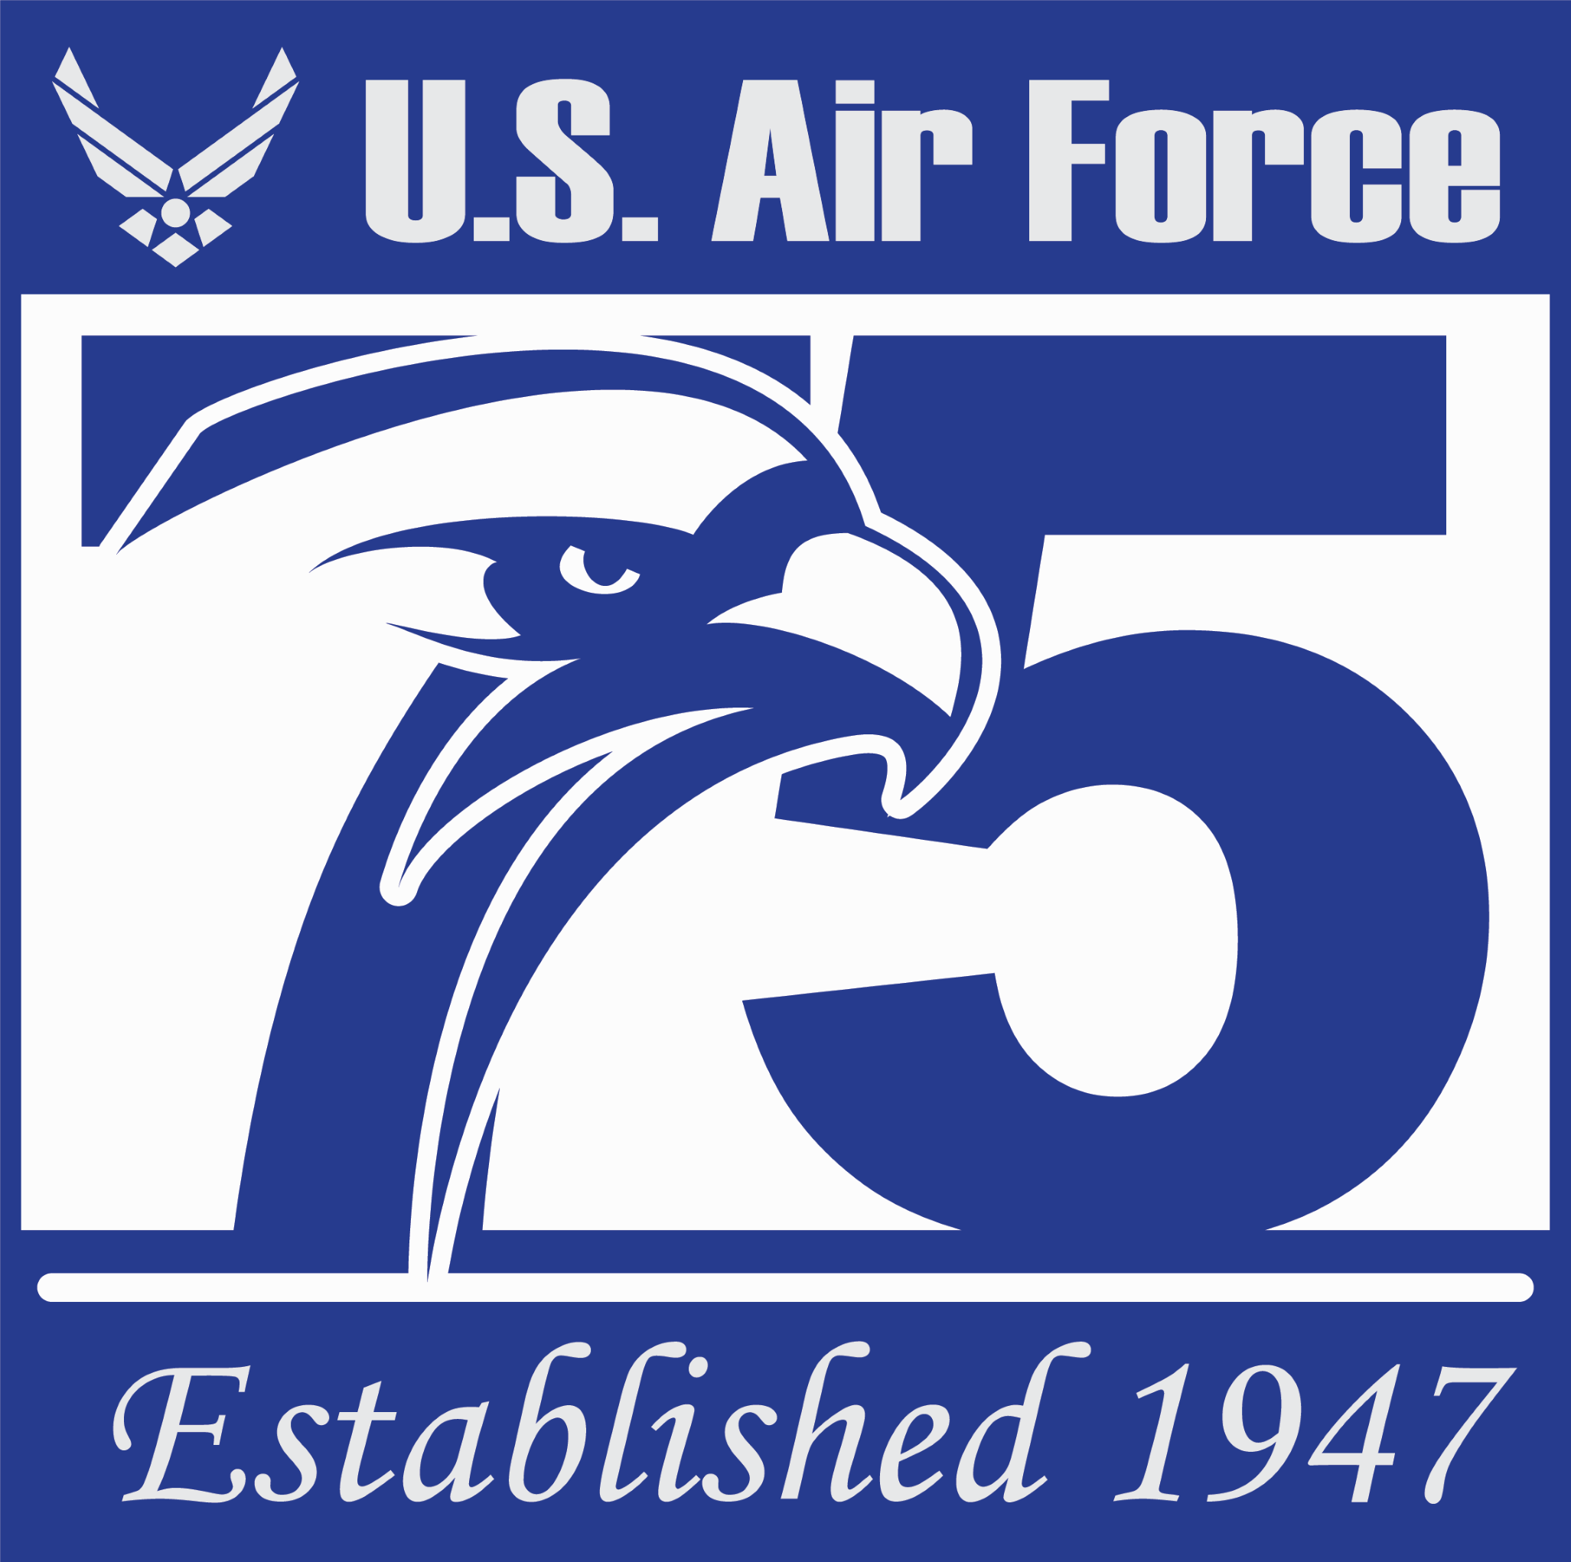
75 Years 1947-2022 -
BEST UNITED STATES
AIR FORCE SUBJECT

- 80 Years - BEST 1942 PACIFIC WAR SUBJECT
- BEST F4U CORSAIR
- RALEIGH WILLIAMS Craftsmanship Award
Visit our website for more info:

