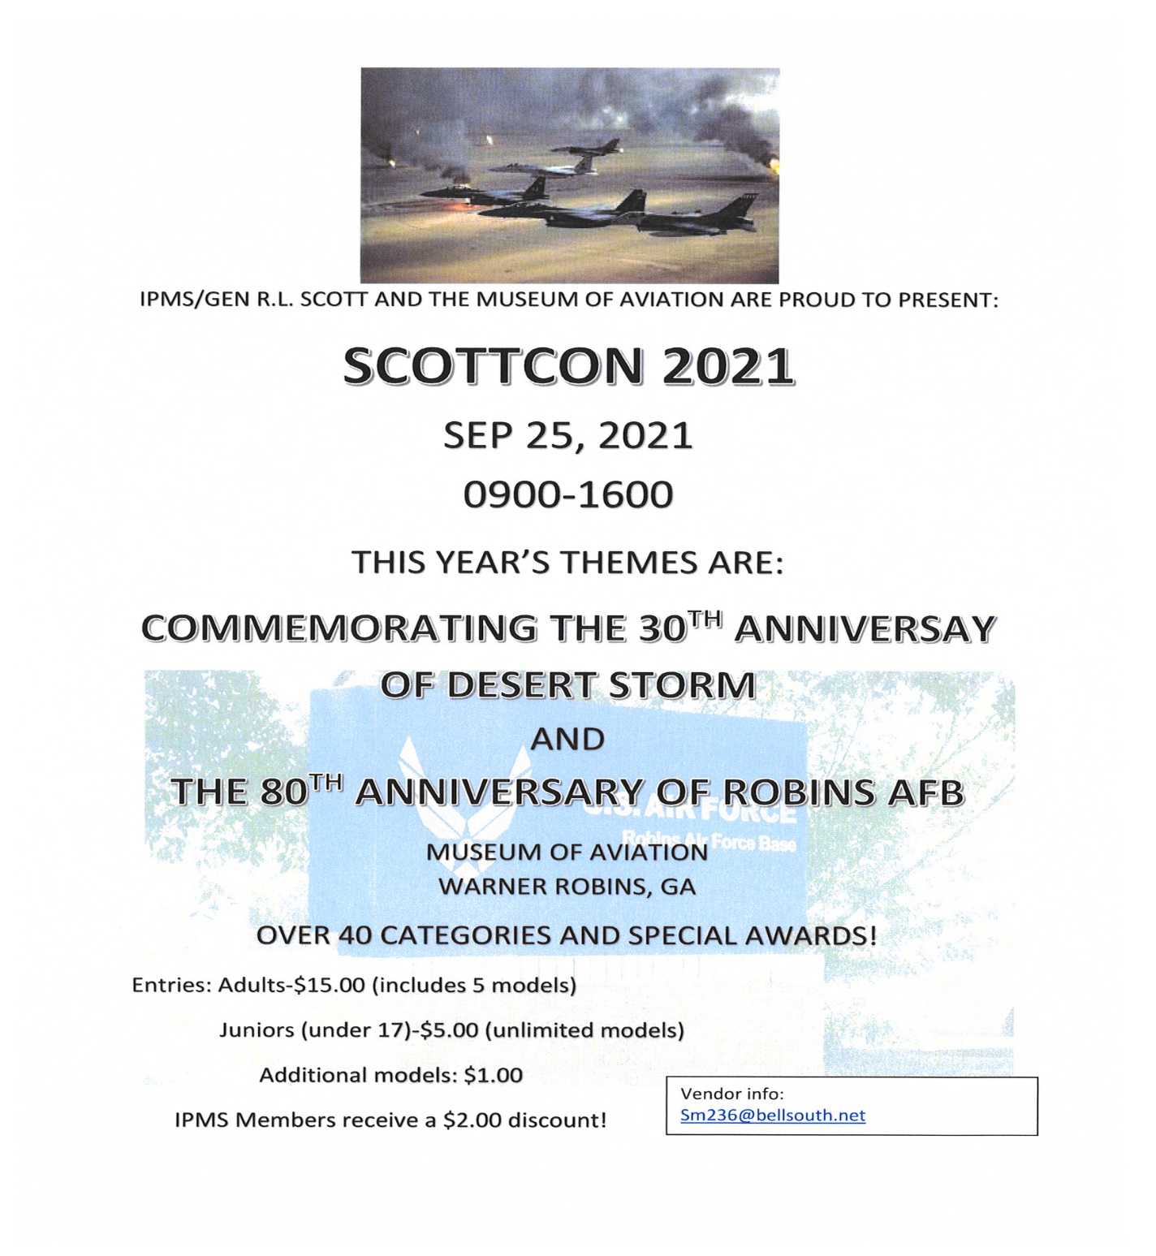
VENDOR INFO
$35/Table or Donate Equivalent in Plastic (Drawing)
Vendor Parking: Not located on the base, no pass required. Enter museum grounds, first road to the right along fence line. Follow road behind a/c to the Century of Flight Hangar on the left side. Park in the rear
Contact Steve Lockhart, sm236@bellsouth.net. (478)919-1006

