SCOTTCON 2022 Fabulous Fifties

JUN 18, 2022
0900-1700

Trinity United Methodist Church
129 S. Houston Rd
Warner Robins, GA 31088
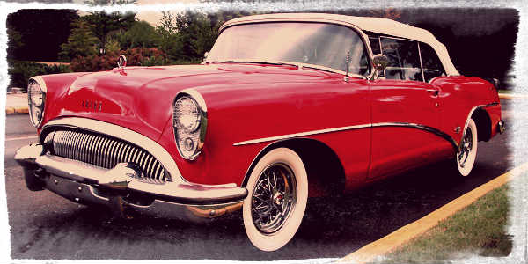
Entries: Adults $15.00 (includes 5 model entry)
Additional models: $1.00
Juniors (under 17) $5.00 (unlimited model entries)
Prizes and raffles!!

Check out our website for details and entry forms.
ipmswr.org

Vendors for more info contact us:
sm236@bellsouth.net

