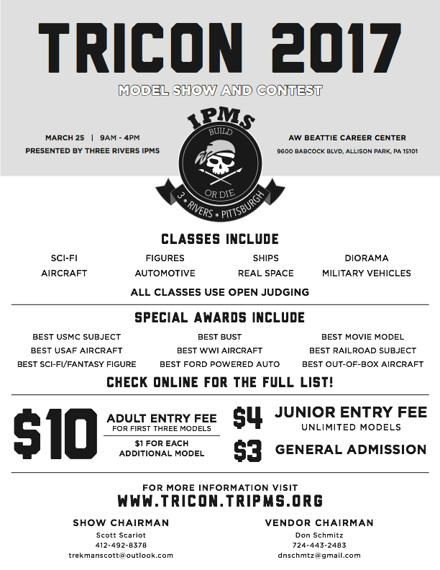

TRICON 2019

$2

30

Contest Registration Closes 1PM